R1M Application
This application introduces how R1M units can be connected via an Ethernet (Modbus TCP/IP) connection (via the 72EM unit) to construct with a large-scale SCADA network.
A maximum of 15 R1M units can be connected within a single area (as shown in the illustration below). The 15 R1M units are then connected to a 72EM module, which allows connection with an Ethernet hub. Via the Ethernet hub, the R1M units are routed to a SCADA network, in this case controlled by Ci Technology’s Citect 5 software. The Citect software allows both server and client PCs for system operation. Please note that the availability of the 72EM is limited only for the use with R1M and Citect 5.
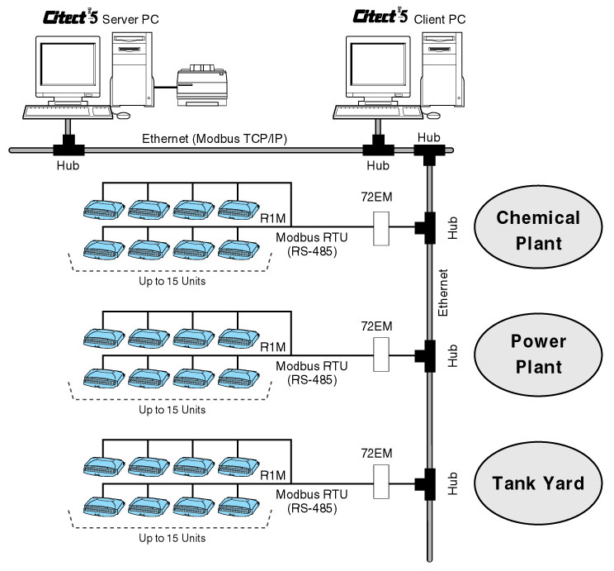
The R1M range includes the following units:
- DC or Thermocouple input: R1MGH2
- RTD or Potentiometer input: R1M-J3
- Contact Output 32 points: R1MD1
- Contact Input 32 points: R1M-A1
- Modbus/Ethernet converter: 72EM
M-System has flexible solutions to meet your specific application and requirements. Consult our Signal Conditioners Data Library. 

