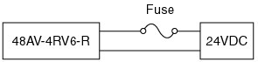

A 0.5 amps fuse is attached to the model 48AV-4RV6-R. When power is turned on, the fuse blows. Why?

First of all, there is no need of a fuse because the 48AV is equipped with one. However, if the user insists on using his own fuse, check characteristics of the fuse and replace it with 1A (for example).
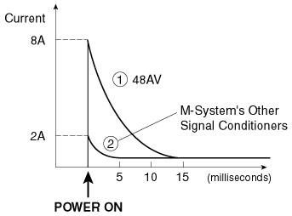
Rush current is the cause of this problem. Power consumption of a transmitter is generally less than 100mA. However, when the power is turned on, large current appears momentarily, called “rush current”.
See the following diagram, the primary circuit of 24 Vdc power. The 48AV is equipped with alarm relay outputs. In order to allow longer momentary power failure duration, the value “C” is designed much greater than the one for ordinary transmitters. It results in much greater rush current.
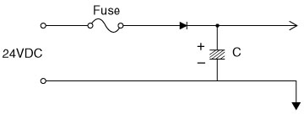
Most complains related with fuses are caused by the rush current.
M-System has flexible solutions to meet your specific application and requirements. Consult our Signal Conditioners Data Library. 

