Liquid Density Measurement – applying Math Function Module
This is a liquid density measuring system using bubble-type liquid densimeter and thermometer as detecting probes for temperature compensation, which can be made effective by Math Function Module. The system configuration is shown in the figure below.
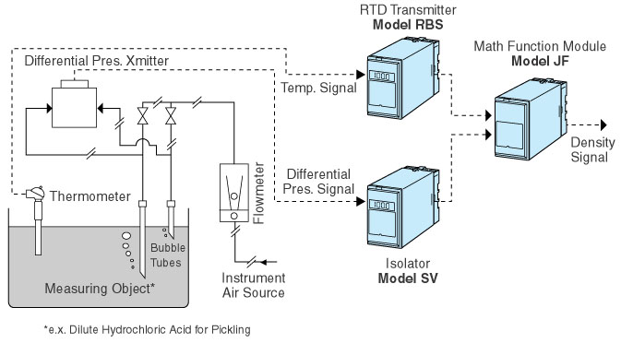
Inherent temperature characteristics for each measuring object are required. Math Function Module can control the temperature compensation characteristics freely and easily by software modification, and thus can be regarded most suitable for temperature compensation computation.
Application Example:
Sheet mill in steel industry has a pickling process for surface treatment of the sheet metal. Dilute hydrochloric acid is commonly used for this process, and it is very important for maintaining the sheet quality to monitor and to control the hydrochloric acid concentration. They hydrochloric acid concentration can be measured through its density, and is regarded as a typical example of the application.
M-System has flexible solutions to meet your specific application and requirements. Consult our Signal Conditioners Data Library. 

