The pH Control in Floatation Process – applying field programmable signal conditioners
The pH control in floatation process used for refining nonferrous metals such as lead and zinc is one of the most severe controls. The reasons are, firstly the long dead time system between chemical feed and pH detection, and secondly the limited allowance of the pH value required for higher gains of floating metals, or yields. In other words, it is necessary to reduce the control hunting which is likely to occur in the dead time system, and also to maintain the pH value within the narrow range which satisfies the conditions.
Now, great performance have been observed in the applications of Dead Time Computing Module model JFT2, Math Function Module model JF, and Linearizer model JFX to this control system for dead time compensation. The outline of the system is illustrated in the figure below.
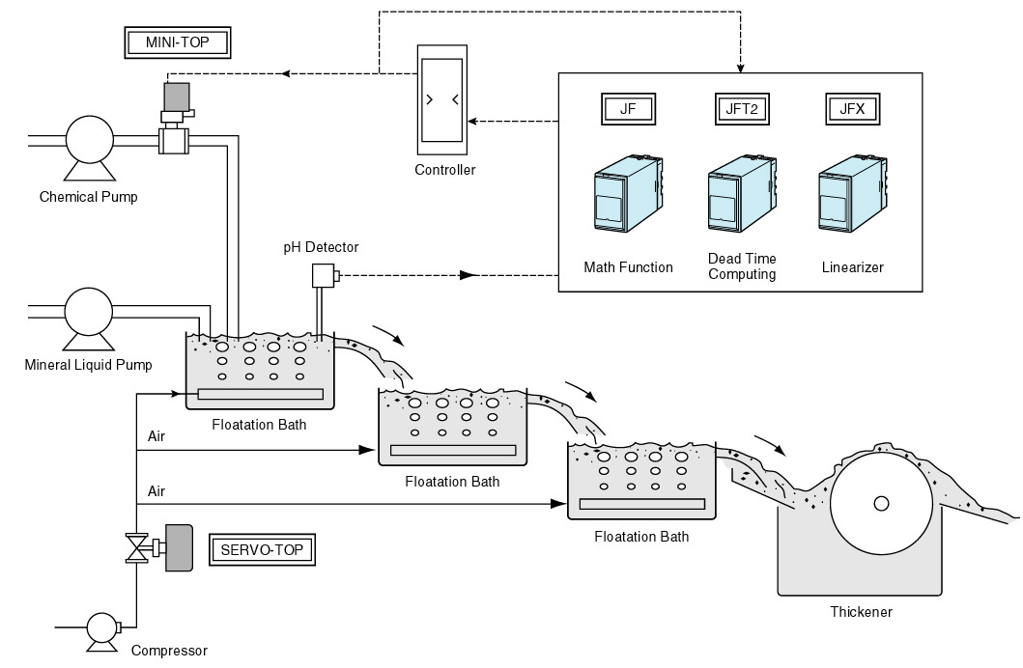
M-System has flexible solutions to meet your specific application and requirements. Consult our Signal Conditioners Data Library. 

