Measurement of Heating Medium Flow Supplied to Heat Exchanger
In heating or cooling processes of materials and products using heat exchanger, the flow of heating or cooling medium fed to the exchanger is measured as one of the basic data for monitoring efficiency of the exchanger. The media feed line is usually designed with a bypass installed right before the exchanger, in order to avoid flow changes which cause variation of the media temperature (see the figure below).
The heating or cooling medium flow may be obtained by subtracting the bypass flow (X₂) from the pumping-out flow (X₁). The Math Function Module is used here for the calculation. In addition, Isolators shown in the figure are used to prevent the electrical noise disturbance caused by relay switching and other sources.
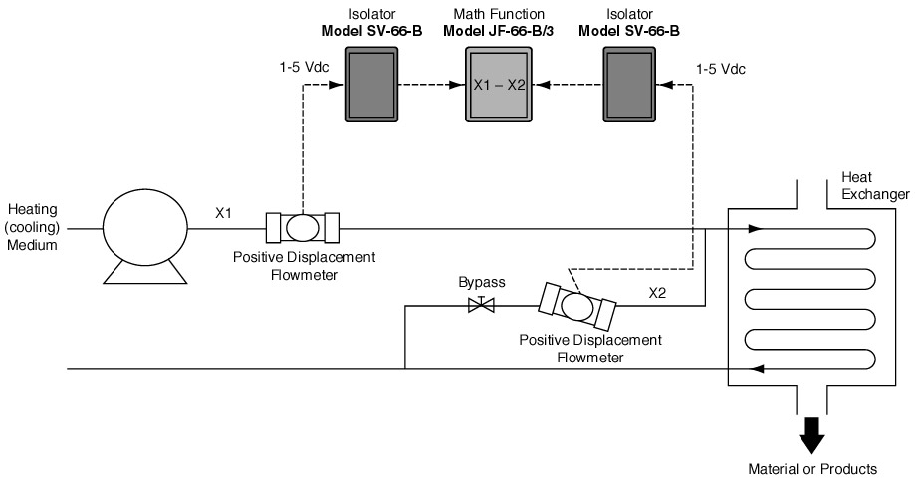
Examples of Measurement range of the Flowmeter:
X₁: 0 to 1000 l/minute
X₂: 0 to 400 l /minute
Examples of Processing Industries Utilizing Heat Exchanger:
Food industry, oils and fats industry, and chemical industry
M-System has flexible solutions to meet your specific application and requirements. Consult our Signal Conditioners Data Library. 

