
I measure wind speed with an anemometer with north as center. Currently 4 – 20mA DC signal corresponding to wind speed 0 – 1000 rpm for north to east direction is indicated on a meter and another 4 – 20mA DC signal corresponding to 0 – 1000 rpm for north to west direction on another meter. I would like to indicate these two signals on a single meter.

Your current measuring system is assumed to be shown above the chain line in the figure below.
The meters accept 4 – 20mA DC signal to show wind speed for respective wind direction. To unify these signals to indicate on a meter, use our Math Function Module (model: JF). The system configuration is shown under the chain line in the Figure below.
Connect 4 – 20mA DC signals from each direction to JF input. Specify addition/subtraction for JF equation, gain/bias parameters, and the output will be provided as 4 – 20mA DC signal. The equation is as follows:
X₀ = K₀ {K₁(X₁+A₁) +K₂(X₂+A₂) } +A₀
(X₀: output, X₁, X₂: input, K₀, K₁, K₂: gain, A₁, A₂, A₀: bias)
In this case, specify K₀=1, K₁=-0.5, K₂=+0.5, A₀=50%, A₁=0% and A₂=0%, and the signal will represent 1000 rpm north-east with 20mA output and 1000 rpm north-west with 4mA output, with 12mA DC as borderline.
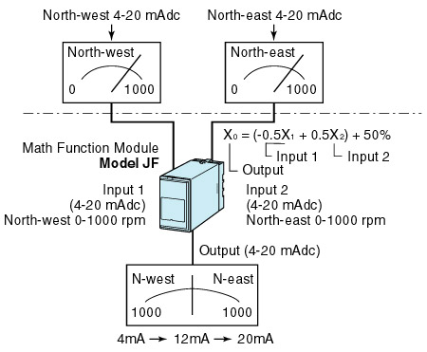
M-System has flexible solutions to meet your specific application and requirements. Consult our Signal Conditioners Data Library. 

