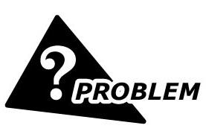
We are planning to input the signal from a level sensor at field to DCS of which 4-20 mAdc input is required. We chose M-System’s Current Loop Supply model YVD?
Three-wire connection is required in the level sensor, however, the YVD is for 2-wire sensor connection as far as I check in the specification sheet.
Do you have any Current Loop Supply unit to meet 3-wire type level sensor, or can I use the YVD for the sensor?
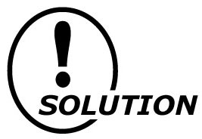
You can use the YVD for 3-wire type level sensor as it is. Because the negative terminals of signal and power supply lines (No.4 and 5. See the figure below) of the YVD is internally connected, the minus line of the 3-wire type level sensor can be connected to either No.4 or 5 terminal of the YVD. The positive of signal line and the sensor excitation are connected to No.3 and No.6 terminal respectively.
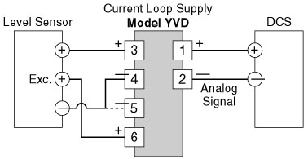
M-System has flexible solutions to meet your specific application and requirements. Consult our Signal Conditioners Data Library. 

