
In order to supply power to two-wire transmitter, we are planning to use your Current Loop Supply model DS-24-_.
The Output 1 will be provided to a recorder, and the Output 2 to a computer. As far as I looked over its specification sheet, I could not find any description of load resistance for each output. Could you tell me these values?

Model DS-24 is a unit to supply a power to two-wire transmitter. As shown in the Figure, the 4-20 mAdc from two-wire transmitter is transmitted to the output terminal of the DS-24 as it is.
In short, the value of load resistance is up to the specification of two-wire transmitter. In case the Output 2 is utilized, after you look over the load resistance of two-wire transmitter, make sure that the total load resistance at the Output 1 and the Output 2 is within the value of load resistance.
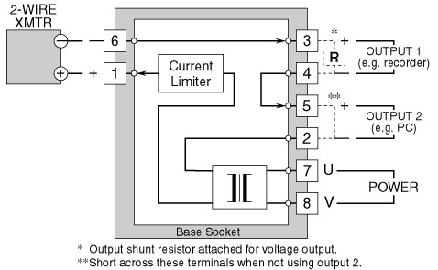
Figure: Circuit diagram of model DS-24
M-System has flexible solutions to meet your specific application and requirements. Consult our Signal Conditioners Data Library. 

