Application of Analog Backup Station
The ABF provides a manual control operation during a computer or DCS failure.
- Simpler and smoother transition comparing from a dual-redundant computer system
- Two indicators: bargraph and digital
- Front pushbuttons for selecting operation mode (cascade or manual), manipulating output (UP or DOWN), etc.
- Manual mode starts at the MV output memories prior to a disturbance in the process.
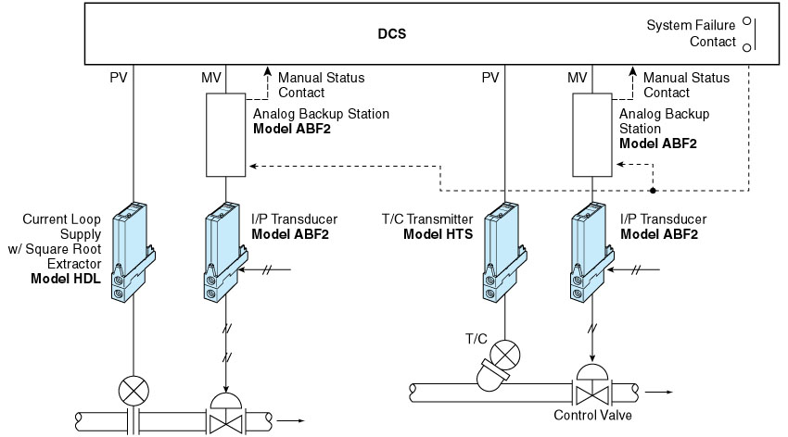
M-System has flexible solutions to meet your specific application and requirements. Consult our Signal Conditioners Data Library. 

