Potentiometer Transmitter — Model M2MS

We are now using the potentiometer transmitter; model: M2MS for the potentiometer (0 to 3k ohms) at site. But we are forced to change this potentiometer (0 to 3k ohms) to another potentiometer (0 to 2k ohms).
Based on the specification of M2MS, this signal conditioner can accept the potentiometer, total resistance 100 ohms to 10k ohms. So we think the same M2MS can be used for the new potentiometer (0 to 3k ohms). But do we need to re-calibrate M2MS for the new potentiometer?

No, you do not need to re-calibrate M2MS again. If the input potentiometer value is within 100 to 10k ohms, you can use M2MS without re-calibration.
M-System’s potentiometer transmitter applies the constant voltage to total resistance R ohms (See the figure below) and get the position in accordance with divided voltage by r ohms.

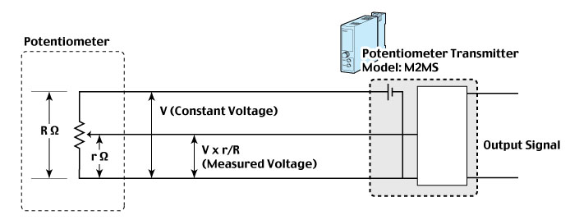

M-System has flexible solutions to meet your specific application and requirements. Consult our Signal Conditioners Data Library. 

