CT/PT Transmitters (Average/RMS) — Model M2CA/CE, M2PA/PE


Now I am looking for transmitter for Current (CT) and Voltage (PT) transformers. But in M-System catalog, there are two category models that are for average and RMS (root means square) sensing. We would like to know how to select the suitable model.

M-System has two models for CT and PT in the following:
For CT: | Model M2CA is the average sensing.
 | Model M2CE is the RMS sensing.
For PT: | Model M2PA is the average sensing.
 | Model M2PE is the RMS sensing.
The average sensing model provides a root mean square value after average calculation. If the input is a perfect sinusoidal wave, both average and RMS model can provide the same output. However, if the input current is distorted by such as thyristor control, the average sensing type cannot provide a correct root mean square value.
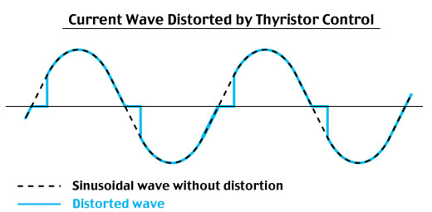
On the other hand, the RMS sensing model can provide a correct root mean square value. When you do not know if the input current or voltage are distorted or not in your application, it is recommendable for you to use RMS sensing model.

M-System has flexible solutions to meet your specific application and requirements. Consult our Signal Conditioners Data Library. 

