Current Loop Supply — Model M2DY

We are planning to measure the temperature of brick making furnace with thermocouple. In
ordinary case we check it in the control room, 200 meters far from the furnace. We also want to check it at the furnace site but we do not have a power for instrumentation equipment there.
Do you have any good idea?

As in the figure below, you can realize your system to use the M-System’s following products,
• Two-wire type thermocouple transmitter (Model 26TS1)
• Two-wire digital panel meter (Model 43AL)
• Current loop power supply for 26TS1 (Model M2DY)
The 43AL digital panel meter does not need an external power and it works at 4-20 mA. The 26TS1 accepts thermocouple and provides 4-20 mA in combination with the M2DY current loop supply.
Both 26TS1 and 43AL are suitable for field-mounting; the 26TS1 in a DIN type B sensor head, and the 43AL can be mounted inside the 6BX-E field enclosure using the A-35 adaptor.

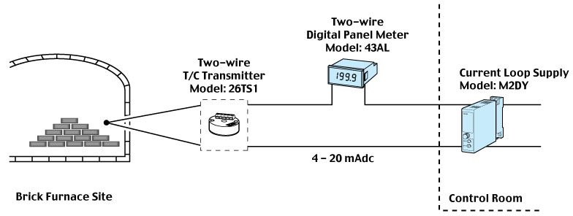

M-System has flexible solutions to meet your specific application and requirements. Consult our Signal Conditioners Data Library. 

