Tachogenerator Transmitter — Model M2TG

We have a conveyor to carry coal. This conveyor feeds the coal to a hopper and we have to keep the volume of coal in the hopper constant. In order to do this we want to control the speed of conveyor which is driven by the motor. The motor has a tachogenerator that provides AC voltage output.
Do you have a signal conditioner which accepts a signal from a tachogeneator?

M-System has the signal conditioner which accepts a signal from a tachogenerator. The model is M2TG. This unit converts an AC voltage from a tachogenerator into a standard process signal such as 4-20mA or 1-5V DC. With this standard signal you can control the speed of motor.
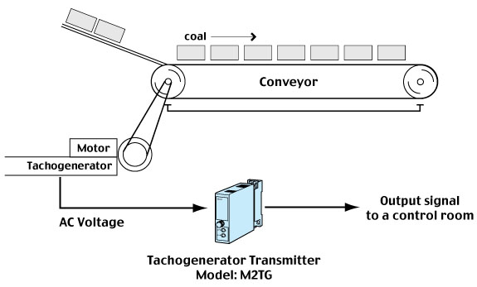

M-System has flexible solutions to meet your specific application and requirements. Consult our Signal Conditioners Data Library. 

