Low Frequency Transmitter — Model M2SP

In the factory we are using the flow meter that outputs the pulse signal. With this signal we want to know an instantaneous flow. Which M-System products do you suggest for this application?

M-System has a Low Frequency Transmitter, model M2SP. This unit accepts pulse input and provides 4-20 mA DC as an output. As the output (4-20 mA DC) is proportional to input pulse, you can see the instantaneous flow.
For more information about Model M2SP, the specification sheet is available at the following location on our web site:
• Access http://www.m-system.co.jp
• Click Data Library icon at the left of the window.
• Choose [Four-wire Signal Conditioners] - [Mini-M Series].
• Locate Model M2SP under [Frequency I/O] on the Mini-M Series products list.

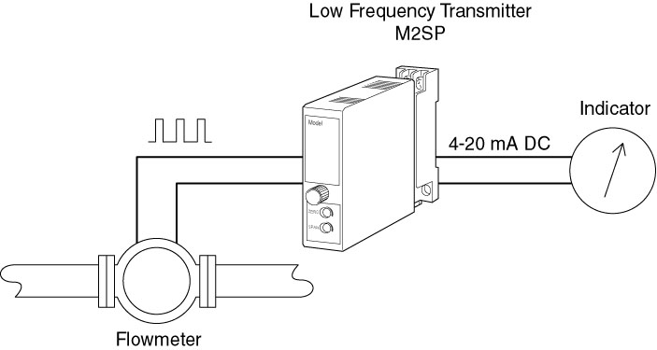

M-System has flexible solutions to meet your specific application and requirements. Consult our Signal Conditioners Data Library. 

