Watt Transducer— Model LTWT

How to determine the VT input value for 3-phase/4-wire configuration for M-System’s watt transducers such as the model LTWT?

Please refer to note under the VT input selections regarding 3-phase/4-wireconfiguration(See the model & suffix code selection to the right.)
For 3-phase/4-wire, the phase voltage (line to neutral) is calculated as the result of line voltage (line to line voltage) divided by root 3. See Figure 1.
Above example applys to:
208V / root 3 = 120V
And, the VT input for LTWT is by line voltage select code 2: 190, 200, 210, 220, 230, 240V AC.
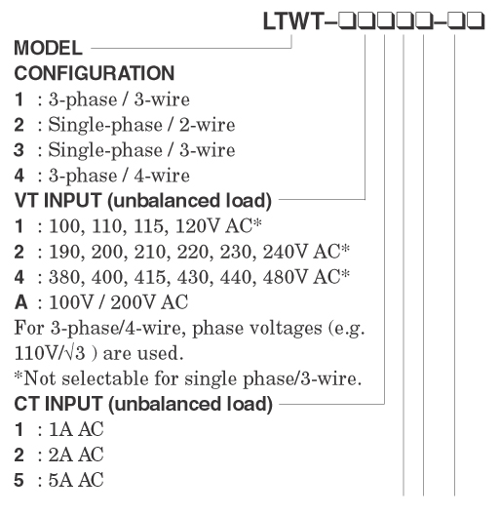
M-System has flexible solutions to meet your specific application and requirements. Consult our Signal Conditioners Data Library. 

