Pulse Divider — Model PDU

We are from an institute of a pharmacy company.
We are thinking of using a math converter to count the pulse signal from a flow meter so as to measure flow volume. The flow meter sends out 1 pulse every 0.333 ml. Now we want to apply a signal conditioner to the flow meter so that it can generate a pulse every 1 ml for the math converter to count. Is there any kind of signal conditioner that can be used for this by purpose?

Please use M-System pulse divider: PDU. With this signal conditioner, the scaling factor 1/n can be easily adjusted. N can be assigned or changed to any value using rotary switch. Also, the duty cycle from PDU can be modulated to feed into the math converter.
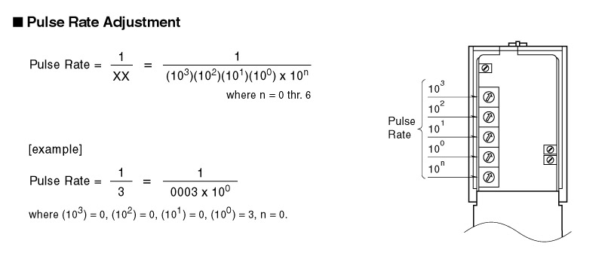
M-System has flexible solutions to meet your specific application and requirements. Consult our Signal Conditioners Data Library. 

