Current Loop Supply — Model M2DY

We have a two-wire type flow meter. The signal from this flow meter needs to be displayed on a bar graph indicator (1-5 VDC). Meanwhile, this signal also needs to be converted to 4-20mA DC and feed into a PLC.
What is the most efficient way to achieve this?


This can be easily achieved by the combination of a current loop supply (M2DY) and a bar graph indicator (48V).
While sending power to two-wire type flow meter, M2DY can accept the signal from flow meter, convert it to 4-20mA DC and pass it to PLC through its output terminals.
Meanwhile, using its monitor terminal #5 and #8, M2DY can convert the signal from flow meter into 1-5V DC and feed it to a 48V bar graph indicator.
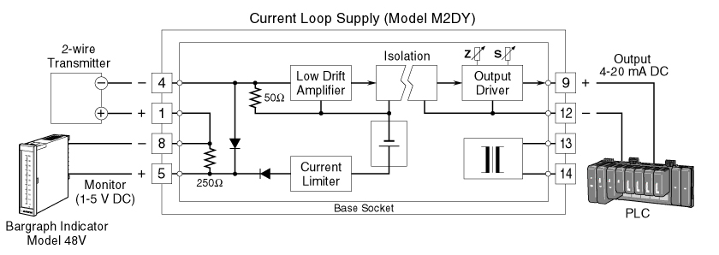

M-System has flexible solutions to meet your specific application and requirements. Consult our Signal Conditioners Data Library. 

