Power Transducer — Model LTWT

We have just integrated two equipment systems together. Now besides the instantaneous power consumption of each system, we also need to monitor the aggregated power consumption as well. Do you have any good advice for this?


You can do this with two M-System power transducer (LTWT) and one pulse adder (JPSM).

Instantaneous power consumption can be monitored by analog outputs from each LTWT. Mean while, with the pulse outputs from LTWT being feed into JPSM, the pulse adder can sum up the total consumption and send the result to a counter. (See figure below)
One convenient feature with JPSM is that the scaling of output can be easily changed with a programming unit (PU-2A). This is useful because the pulse unit of LTWT is determined when order is placed and can't be changed later. However, if for some reason the pulse unit doesn't match the system and have to be changed later, we can achieve this indirectly by adjusting the scaling on JPSM.
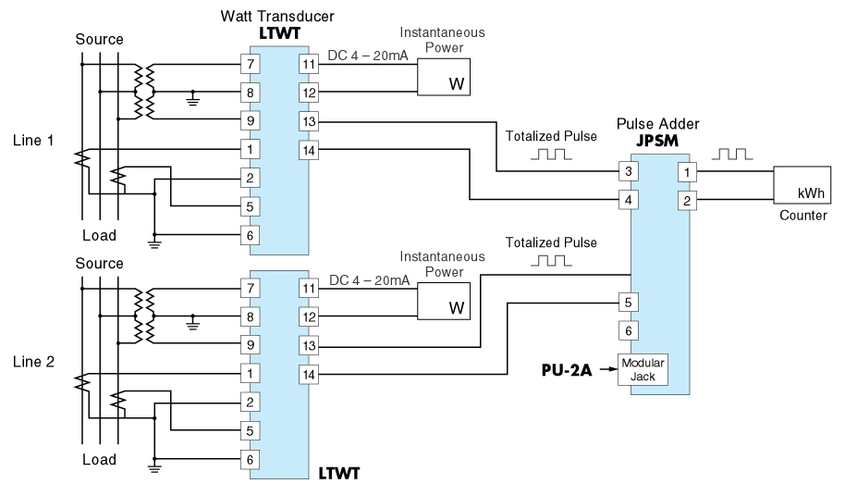
M-System has flexible solutions to meet your specific application and requirements. Consult our Signal Conditioners Data Library. 

