Thermocouple Alarm — Model AET

To monitor the temperature in incinerator, we are thinking of using a thermocouple sensor to send 4-20mA signals to control room. Meanwhile, we also need an alarm device at field in case the temperature goes out of range. What can you propose for this application?


Our Thermocouple Alarm AET provides the right features needed in this application.
Besides its two point alarms, AET has a DC output also. Therefore it is capable to initiate the alarm at field while sending temperature signal to control room.

AET is equipped with thumb rotary switches in the front for alarm point setting and deadband setting. So it's convenient and easy to use.

In our AE series, we have sorts of similar alarms for various input types from DC current, potentiometer, pulse, PT. CT and many others.

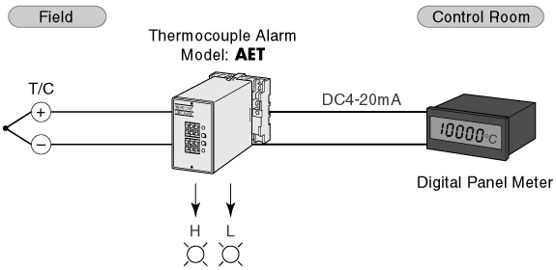

M-System has flexible solutions to meet your specific application and requirements. Consult our Signal Conditioners Data Library. 

