Lightning Surge Protector for RTD Use — Model MDP-RB


We are using universal input transmitter, M3LU with 4-wire RTD sensor.
We’d like to install lightning surge protector for this system. Does M-System have any lightning protector for 4-wire RTD sensor signal use?


The M-System Model MDP-RB RTD’S sensor signal use lightning protector would be fit for this application. To protect both sensor side and transmitter side, please use 4 pcs. of MDP-RB. 2 pcs. for sensor side and the other 2 pcs. for transmitter side.
Please refer below wire connection method.
By this means, the M3LU can take in 4-wire RTD sensor signal with full lightning surge protection measures.

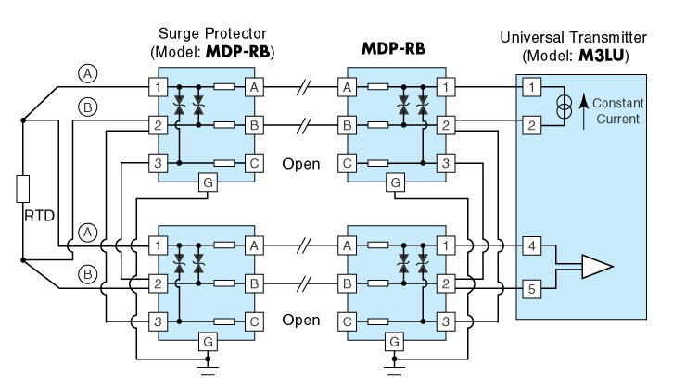

M-System has flexible solutions to meet your specific application and requirements. Consult our Signal Conditioners Data Library. 

