CT Alarm — ALCT


We are fish farmer. There are 2(two) illuminating lamp beside a farm pond and these lamps are turned on all the time. For prompt system recovery purpose, we’d like to have alarm contact signal when the lamps could be run off or failure. Does M-System have any limit alarm unit for this purpose? We are using 60W illuminating lamp that is supplied 100V AC power input.


The M-System CT Alarm, model ALCT should be fit for your application. The ALCT can take in 0 – 5A AC signal and provide 2(two) SPDT relay outputs. When power consumption is 60W, the current is 0.6A (60W / 100V), when power consumption is 120W, the current is 1.2A (120W / 100V).

Therefore, you should set the alarm setpoints at 1A (20% of full span) and 0.5A (10% of full span). With this setting, you can get each alarm signal when 1(one) lamp is failure and 2(two) lamps are failure.

Alarm output is SPDT so that please wire this alarm contact outputs to alarm pilot lamps.

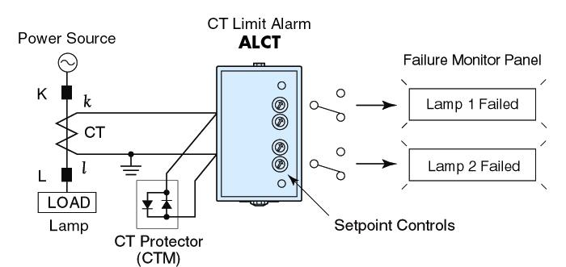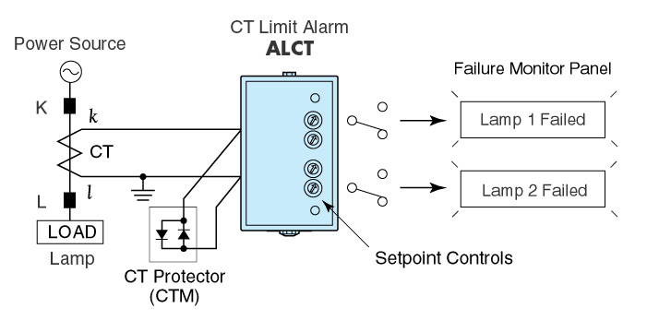

M-System has flexible solutions to meet your specific application and requirements. Consult our Signal Conditioners Data Library. 

