
There is a deck gun for fire protection in a garbage incinerator site. We are thinking to use a potentiometer for detecting the traverse angle and elevation angle of the deck gun. We want to transfer the angle signal to a control room at 200-meter distance from the field. We’d like to minimize the field panel size as much as possible, hence we think to install a potentiometer transmitter at the control room and wire the signal from the field’s potentiometer sensor to the control room. Is this a realistic idea for us to wire the sensor for 200 meters?


Wiring the potentiometer sensor signal line for 200 meters distance is not a good idea because the sensor’s output voltage signal is particularly vulnerable to noise.

We recommend you to install our two-wire potentiometer transmitter, B5MS in the field panel. The B5MS can convert the potentiometer angle signal to a standard 4-20mA signal and send it to the control room through current loop supply, the M5DY. A 4-20mA signal is strong against noise so that you can wire it for 200 meters without worry.

Both B5 and M5 series transmitters are sized very small, so you can design panels in the field and control room easily.
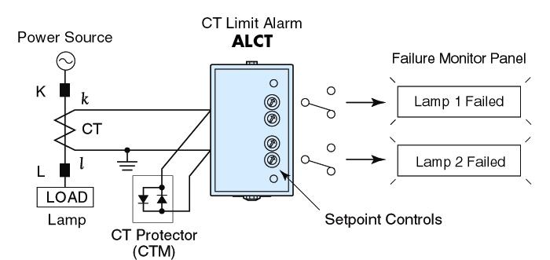
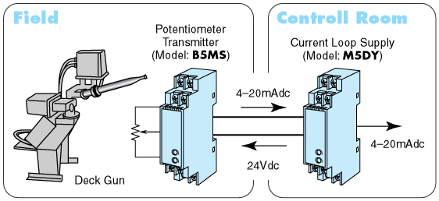

M-System has flexible solutions to meet your specific application and requirements. Consult our Signal Conditioners Data Library. 

