Averaging Two Signal

The customer is a printing company who is producing LCD color filters and supplying them to many electron companies. To keep the color filter's good quality, they use a clean room in their factory manufacturing process. There are 2 (two) pressure sensors in the clean room. Each sensor's output is a 4-20mA DC. They want to control the clean room's fan inverter system in proportion to the average output of the 2 (two) pressure sensors. Therefore, they need to get an average value of two pressure sensors as a 4-20mA DC standard signal.
Does M-System have a suitable adder unit for this application?

M-System's Model M2ADS will fit your customer's application.
The M2ADS receives two DC inputs and provides an output proportional to the addition of the inputs. If you need an average value of two pressure sensors' outputs, please specify each input ratios for the M2ADS as K1=0.5 and K2=0.5.
The equation for this unit is, Output = K1 x Input 1 + K2 x Input 2.
For example, when each pressure sensor's outputs are 40% (10.4mA) and 60% (13.6mA), then the output of this M2ADS unit will be 50% (12mA).
For this case, equation is as below,
Output = K1 x Input 1 + K2 x Input 2
= 0.5 x 40% (10.4mA) + 0.5 x 60% (13.6mA)
= 0.5 x 0.4 + 0.5 x 0.6
= 0.2 + 0.3
= 0.5
The output proportion will be 0.5 (=50%), it means you will get 12mA DC output from this M2ADS.
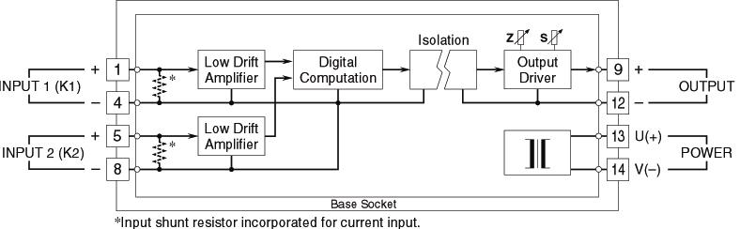
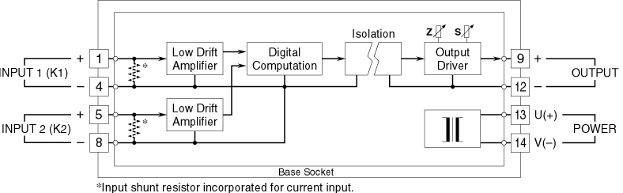

M-System has flexible solutions to meet your specific application and requirements. Consult our Signal Conditioners Data Library. 

