Indicating Temperature Difference

We are looking for a differential RTD transmitter in order to measure a temperature difference between 2 rooms. And displaying it on indicator as voltage scaling, -5 to +5V DC.
We know M-System has a differential RTD transmitter, the DR/DRS but it can accept just 2-wire RTD signals. Does M-System have this kind of transmitter that can accept 3-wire RTD signals?

We recommend you to use 2 units of the M2RS as combination. If you specified the outputs as 0 to 5V DC of each M2RS unit and connect the output wires shown as below connection diagram then you can get -5 to +5V DC to display the temperature difference on the indicator.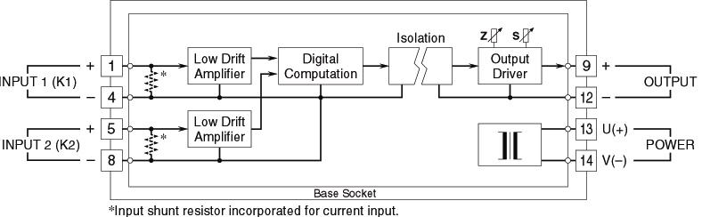
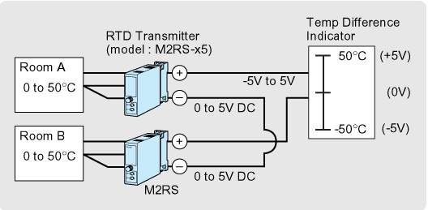

M-System has flexible solutions to meet your specific application and requirements. Consult our Signal Conditioners Data Library. 

