200 mA Output Transmitter — SVA

We have replaced an old, out-of-order pressure transmitter which outputs 10-50 mAdc. The new one, on the other hand, outputs 4-20 mAdc, so we have also purchased a 4-20 mA current loop supply model M2DY-A-M to power the transmitter.
The only instrument we do not want to replace is the expensive receiving instrument in the control room which is suitable only for 10-50 mA signals, and is still in good working order.
We have to find a way to convert 4-20 mA into 10-50 mA signals to maintain the compatibility between the field and the control room.
Does M-System have a suitable transmitter for this application?


Please consider to use M-System’s signal transmitter, model SVA. The SVA can outputs 10-50 mAdc with 2000V isolation. This unit can connect at the maximum of 400 ohms as load.
The full part number should be SVA-AH-K3 ( in case power input 100-120 Vac).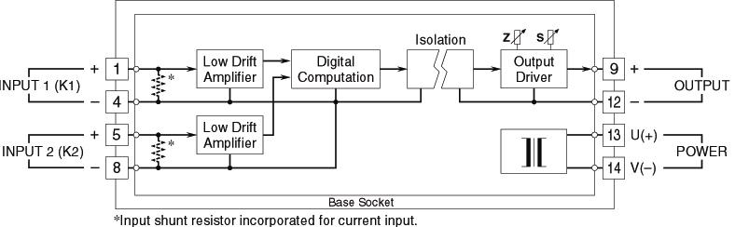
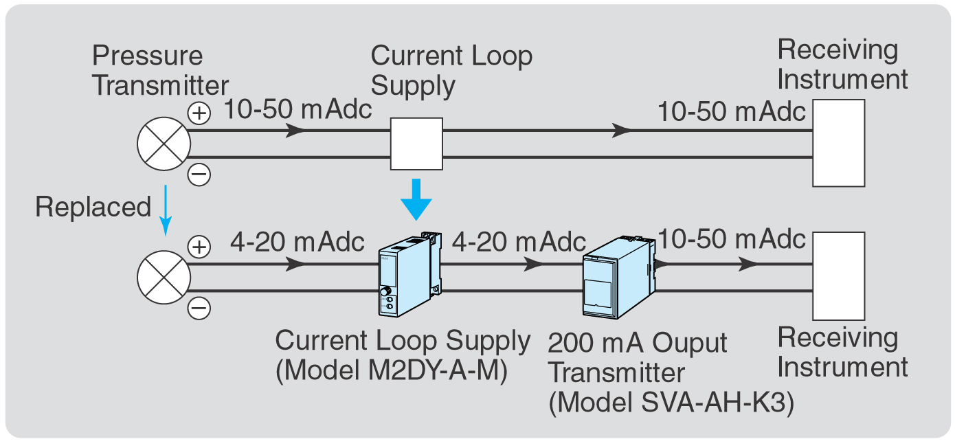

M-System has flexible solutions to meet your specific application and requirements. Consult our Signal Conditioners Data Library. 

