Isolator & Loop Powered Indicator
We are preparing UPS in our power monitoring system for system backup purpose in case of blackout. On a power monitoring panel, we also want to monitor UPS's charging condition by using digital indicator. Does M-System have any transmitter for this application? For your reference, our UPS's battery capacity is 12 Vdc at full charging.



We'd like to introduce the signal transmitter, M2VS and the DC panel meter, 43AL.
Please specify the M2VS of its input as 0-12 Vdc and output as 4-20 mAdc. DC panel meter, the 43AL can be connected to the M2VS's output and display the UPS's battery condition as 0 to 12.00 on its LED.
You can scale easily with using potentiometer on the top of the 43AL unit. For example, you can monitor as percentage scale (0 to 100%) of UPS charging condition.

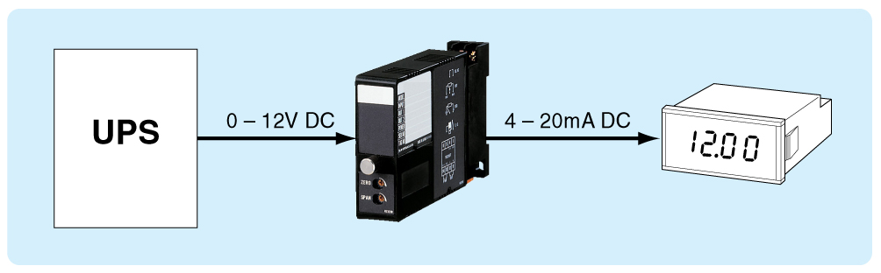

M-System has flexible solutions to meet your specific application and requirements. Consult our Signal Conditioners Data Library. 

