Tap Water Supply Leakage Alarm
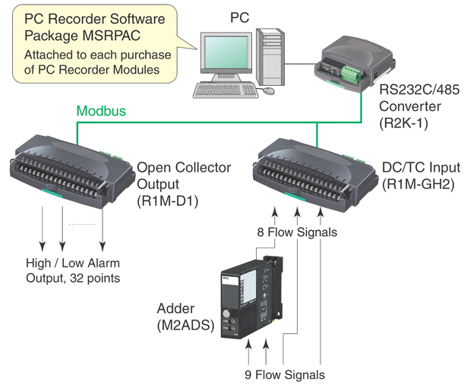
M-System’s PC Recorder MSR128 series is a Windows-PC-based recorder software program, which connects to economical I/O modules such as models RZUS, RZMS, R1M, R2M, R3 and R5 for DC mV, mA, thermocouple, RTD/potentiometer inputs and discrete I/Os. MSR128 is a fully featured program enabling the logging, trending acquisition and analysis of application data. Combined with I/O modules, MSR128 provides a low cost industrial grade data acquisition system.

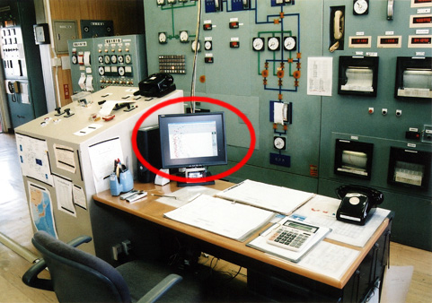
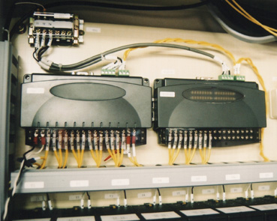
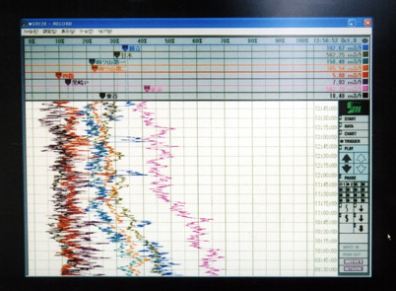
This application is introduced from one of the waterworks department in Japan using PC Recorder.
In general, tap water is distributed through water supplying pipe networks in underground. There is the possibility of water leakage by corrosion of pipes. When the water supply pressure is increased, there will be more leakage. When the pressure is lowered, there will be a problem during high usage time period and elevated locations including condominium buildings, office buildings and such.
Minimizing the loss of water supply and constantly supplying water is necessary.
Additionally, there is a danger from earthquake damage (natural disasters), accidental damage by heavy equipment used for road construction (man-made disasters), deterioration by corrosion, which cause destruction of water supply pipes. For monitoring water leakage, PC Recorder is used.
Flow signal transmitted from distribution reservoirs (Reservoir Area) by the telemetering system is monitored at the central monitoring system. Also inputting signal to a PC Recorder via R1M-GH, showing trend graphs on the screen. System configuration per Figure 1, nine (9) flow signals are covered (due to the record view is per 8-pen, two signals are added by model M2ADS beforehand).
The alarm output is provided by model R1M-D1 module, enabling to sound a buzzer.
Leakage alarm is not detectable only by abnormal over discharge range because high usage also can be a case. Flow from every distribution reservoir shows similar trending chart daily. If significant water leakage occurs, the tending chart will be noticeably different.

