Backup hold & manual loading for the PID controller output failure
We use a PID controller to open and shut a valve with 4-20 mA control signal. We are looking for a manual loader which can take 4-20 mA input and output 4-20 mA. We want to use a contact input to tell whether the output should be tracked or held. If the output is to be held then we need it held at 4 mA.


We recommend M-System Analog Backup Station, Model JB.
The JB accepts 4-20 mA (CAS input) and passes it through to output as 4-20 mA (MV output) in normal operating conditions.
Please refer to the circuit diagram (Figure 1). When the external MAN command relay (terminal 8) is closed, the JB turns to manual control mode (MODE 3). In this mode you can hold the output at a specific preset value (like 4 mA). If you need to change the hold value on site, then you can use the Programming Unit, PU-2A.
As for other manual control modes, please refer to the descriptions below:
When the external MAN command relay is closed, the JB turns on to manual control mode. Actual output signal is determined by following three operation mode.
MODE 1 : Hold the CAS control signal at the moment of the MAN command.
MODE 2 : Go back the preset time period and hold the CAS control signal at that moment.
MODE 3 : Hold a specific value preset by the Programming Unit (PU-2A).
In each mode, the output can be manipulated with external UP or DOWN commands (Figure 2). When the MAN command relay is opened, the CAS control signal is recovered with smooth transition.
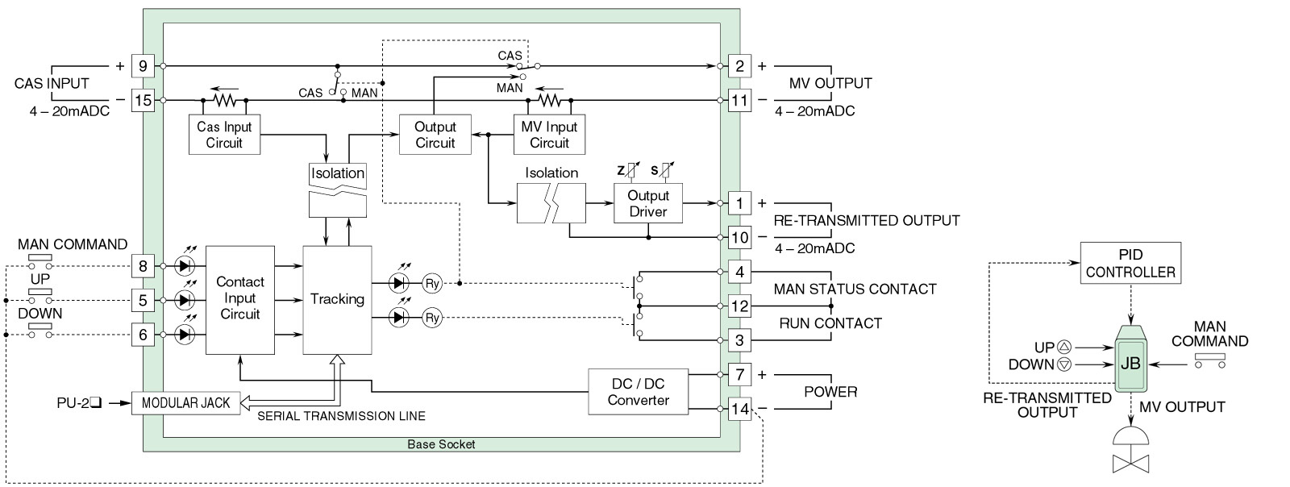 Figure 1. JB circuit diagram. Figure 2. JB manual control function.

