Power Monitoring System
M-System’s PC Recorder MSR128 series is a Windows-PC-based recorder software program, which connects to economical I/O modules such as models RZUS, RZMS, R1M, R2M, R3 and R5 for DC mV, mA, thermocouple, RTD/potentiometer inputs and discrete I/Os. MSR128 is fully featured enabling the logging, trending acquisition and analysis of application data. Combined with I/O modules, MSR128 provides a low cost industrial grade data acquisition system.

This is the power monitoring application at a plant.

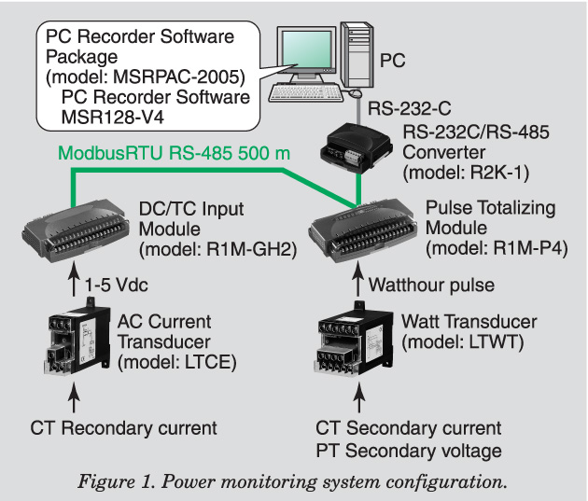
In general, the electricity rates contract between the power companies is classified for three types, ultra high voltage (66 kV), high voltage (6600 V) and low voltage (200 V). This application is based on the user contracted high voltage power receiving, 500 kW max.

Electricity charge is the sum of basic charge and usage charge. Basic charge is set based on the maximum 30 minutes usage in the period for past 11 months and for the month. Usable power consumption for 30 minutes is contracted with the power company, which is called the “demand contract”. If exceeded the contracted usable power, penalty will be charged and next 12 months follow will be at higher basic charge by overly used rate. For that reason, to reduce electricity charge, it is necessary to reduce the basic charge, which is 30 minutes of power consumption.

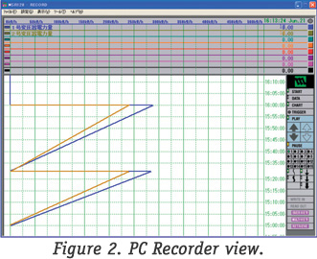
Historically, “demand monitoring system” for entire plant is widely used by many end users. However, commonly it is controlling the power supply for the whole plant but not detailed for the power consumption per facility. As a solution, M-System’s PC recorder is adopted to use for monitoring per facility.

Figure 1 is the system configuration. Installing LTWT (watt transducer) at each facility’s electric power inlet, its pulse output (kWh) to input into R1M-P4’s totalized counter input, then display on PC recorder (Figure 2). Counter reset by external contact input enables at pulse rising. Using the timer relay to reset 30 minutes interval, power monitoring is available like as the demand monitoring.
Also, by using LTCE (current transducer), the current monitoring can be used as reference to the usage of power. Power is the result of voltage x current, the voltage is constant so measuring current will be informative to know which facility is consuming power the most. Through R1M-GH2, the PC recorder is available to display real time trend of the amount of power consumed by each facility.

