Motor Load Current Measuring

In order to monitor an electric power system in the factory, we monitor the load current of each motor equipped in each assembling line. We’d like to convert the motor load current into 1-5 Vdc standard signals and put it to existing data monitoring instrument.

However, there is a strict budget limit then we like to achieve this system with low price as much as possible. Does M-System have any solution?


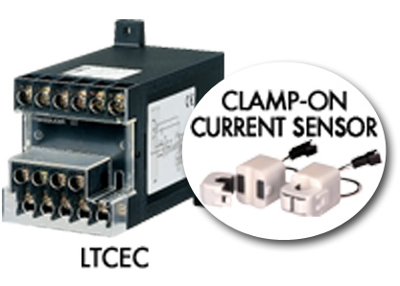
We recommend you to use the clamp-on current sensor input type AC current transducer, the LTCEC. The LTCEC includes easy-to-install clamp-on current sensor therefore you don’t need to prepare any CT transformer. This will enable you to reduce worker-hour cost for re-wiring of power line and/or wire penetration. As a result, you can expect the total cost reduction for equipment expenses.

As for input range of the LTCEC, it covers wide input range from 0-10 Aac to 0-500 Aac.

Plug-in type modules, model CTC (M-UNIT Series) and KCEC (K-UNIT Series) are also available.

