Monitoring at Multiple PCs via Ethernet
M-System’s PC Recorder MSR128 series is a Windows-PC-based recorder software program, which connects to economical I/O modules such as models RZUS, RZMS, R1M, R2M, R3 and R5 for DC mV, mA, thermocouple, RTD/potentiometer inputs and discrete I/Os. MSR128 is fully featured enabling the logging, trending acquisition and analysis of application data. Combined with I/O modules, MSR128 provides a low cost industrial grade data acquisition system.

This is the application of monitoring the utility systems at a plant using multiple PC units over Ethernet.

In general, the utility systems at the plant including Electricity (receiving power, substation, power generation), Steam, Compressed air, Nitrogen, Air-conditioning (Chilled water), Service water, Wastewater facility, and etc.
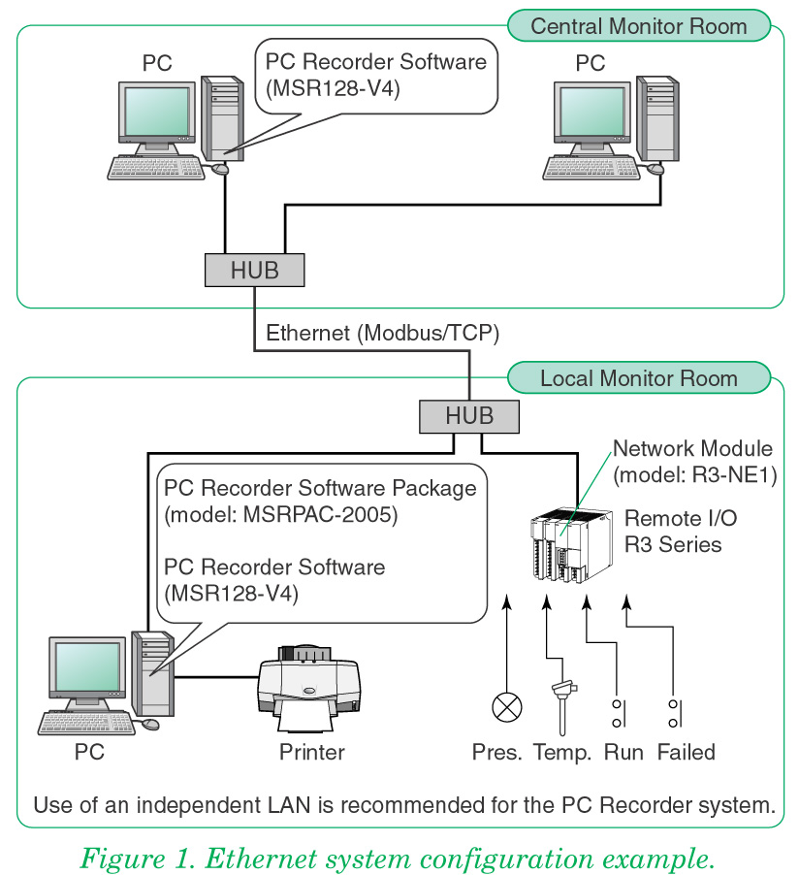
At these facilities, there are used the analog signals of voltage, current, power, water level, temperature, pressure, flow and discrete signals to start/stop and detecting failure of the pump/blower.

Monitoring these signals of knowing total energy usage, achieving energy savings will be available. Data monitoring is required in many sites to comply with more severe environmental concerns such like ISO14000.

Various data signals are input by using remote I/O units of R1M, R3 and R5 series. Connected to a PC installed with recorder software MSR128-V4, analog data and alarm monitoring is available.

Communication protocol is used the Modbus. Using Modbus/RTU the number of host PC is limited to a single unit. By using Ethernet Modbus/TCP, maximum 2 PCs can be used.

Per Figure 1, monitoring with multiple PCs in central supervision room in remote location is available by using Modbus/TCP.

