Upgrading Local Paper Recorder to Network Recording System
M-System’s PC Recorder MSR128 series is a Windows-PC-based recorder software program, which connects to economical I/O modules such as models RZUS, RZMS, R1M, R2M, R3 and R5 for DC mV, mA, thermocouple, RTD/potentiometer inputs and discrete I/Os. MSR128 is fully featured enabling the logging, trending acquisition and analysis of application data. Combined with I/O modules, MSR128 provides a low cost industrial grade data acquisition system.

This is the application of monitoring temperature of refrigerated storage.

The customer was using chart recorder before. They had to have many units to monitor each of refrigerated storage. Daily maintenance was required constantly at some of those storages had troubles by blockage of ink, out of ink, paper jam, out of paper and etc.

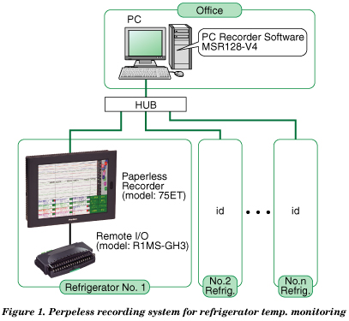
To solve the problem, they replaced them with M-System’s Paperless Recorder, Model 75ET, which utilized existed panels and temperature sensors (thermocouples). With the panel mount adaptor model A-75, the 75ET fits into a DIN-sized cutout (281 x 281 mm) of the chart recorder was mounted. Compact size R1MS has channel-to-channel isolation and takes in signals directly from the thermocouples. Recorded data is stored in compact flash card. No more paper jam and ink problems. It eliminated the running cost of the supplies and labor.

The 75ET has Ethernet interface, which provides the access from a PC located in the office on a LAN. Ethernet communication transmits data of specific channels stored in real time to a host PC installed with the PC Recorder Software Model MSR128-V4. Data stored in the CF Card can be uploaded to the MSR128-V4 using FTP protocol.

