Power Demand Monitoring System

We plan to monitor the amount of power usage of each facility in our factory. Because we set up “Demand Contracts” with Electric Power Company, we do monitor the receiving power amount. In addition, we’d like to confirm the status of power use of each facility.

Does M-System have suitable system or module?


We’d like to propose you to install the power transducer, model LTWT at each electric power inlet point. The LTWT take in AC active power and provide a DC output signal and pulse signal proportionally. And then please put the pulse output signal into the PC Recorder module, the R1M-P4. The R1M-P4 takes in the pulse signal as totalized counter input.

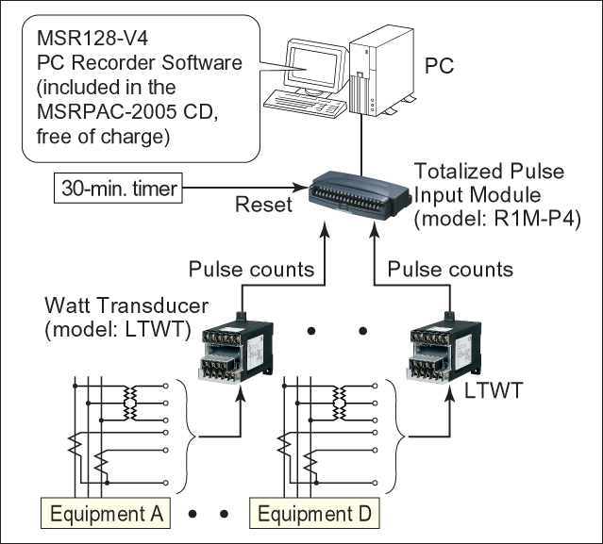
You can monitor the totalized pulse record on the PC Recorder software on your PC via RS-232C. PC recorder software, MSRPAC-2005 is coming along with the R1M-P4 for free of charge. The R1M-P4 has counter reset function. Therefore if you need to monitor every 30-minute amount of power, please set an external timer-controlled relay and apply a contact input to the R1M-P4 in every 30-minute as counter reset signal.

Demand Monitoring Contract (example in Japan)
Amount of power usage in every 30-minute is contracted between Power Company and Commercial-Scale utility customers. It is called “Demand Monitoring Contract” in Japan. If customer’s amount of power usage goes over the contracted limitation, penalty charges will be required and/or next coming amount of power contraction will be expanded automatically.

