Test Data Monitoring for Solar Power Generation System
M-System’s PC Recorder MSR128 series is a Windows-PC-based recorder software program, which connects to economical I/O modules such as models RZUS, RZMS, R1M, R2M, R3 and R5 for DC mV, mA, thermocouple, RTD/potentiometer inputs and discrete I/Os. MSR128 is fully featured enabling the logging, trending acquisition and analysis of application data. Combined with I/O modules, MSR128 provides a low cost industrial grade data acquisition system.
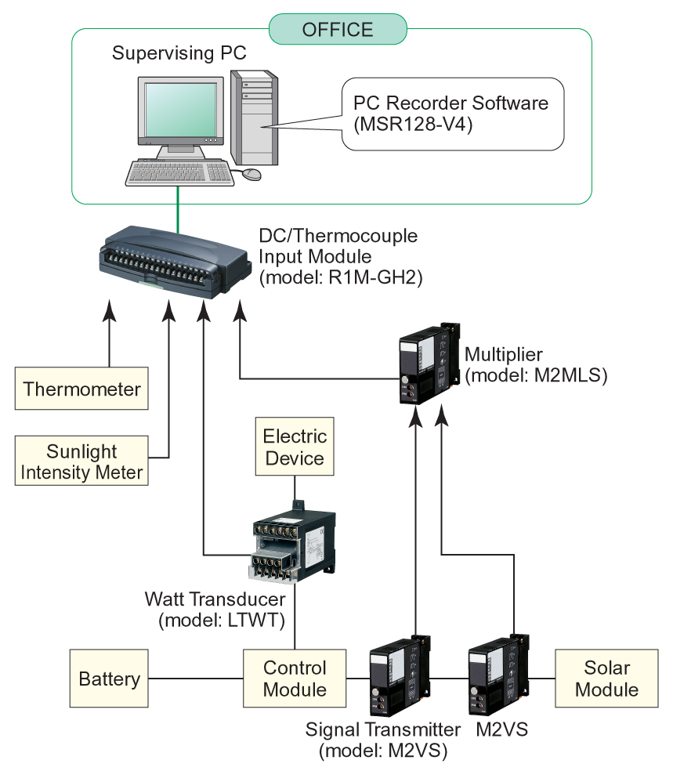
This is the application of monitoring data from a solar power generation system. The customer is a manufacturer of solar power generation systems. They are using our PC recorder for data acquisition of newly developed systems’ trial operation. The research project they have been working with is NEDO (New Energy Development Organization). Because the testing period is only a year and their budget is limited, our PC recorder was ideal to do their job.

Their system generates power, then uses the stored energy to illuminates a neon billboard at night. Monitored data is: generated energy, consumed energy by neon billboard, intensity of daytime sunlight and outside air temperature.

The generated energy by the system is DC but the neon billboard use AC, which need a DC/AC converter. The following M-System’s modules are used for the power monitoring.

AC power: LTWT
DC power: M2VS (DC voltage), M2VS (DC current), and M2MLS (Multiplier)

Using a R1M-GH, the trend data is monitored by the PC, which has MSR128-V4 recorder software installed.

