Water Level Measuring & Indication

We plan to measure water levels of inside and outside of water gate by water-level gauge. We’d like to display the water level difference between the two gauges. On the panel, we like to display them as follows:

No water level difference: Display as 0.00 m
Inside gate 100%, outside gate 0%: Display as 5.00 m
Inside gate 0%, outside gate 100%: Display as -5.00 m

The signal from each water-level gauge is 4-20 mAdc. Also we plan to use a 4-20 mAdc input type panel display unit. Does M-System have a suitable unit?

We like to recommend the combination use of 2-input Math Function Module (Model: JF) and a DC Input Digital Panel Meter (Model: 46DL).
As for this time request, please specify the JF’s equation as Subtraction (suffix code as /3 ). And for each parameter, please specify the gain K1 as 0.5, the gain K2 as -0.5 and the bias A0 as +50%. The K1 is gain of input 1 (= inside gate value), the K2 is gain of input 2 (= outside gate value).
By the above parameter setting, the JF unit will output 12 mA when there is no water-level difference between inside gate and outside gate. As for each input/output relation, please refer followings,
Example 1
Input 1: 12 mA (50%)
Input 2: 12 mA (50%)
Output: 12 mA (50%)
Output = (K1 x input 1) + (K2 x input 2) + A0
= (0.5 x 0.5) + (-0.5 x 0.5) + 0.5
= 0.25 – 0.25 + 0.5
= 0.5 (= 50% = 12 mA)

Example 2
Input 1: 20 mA (100%)
Input 2: 4 mA (0%)
Output: 20 mA (100%)
Output = (K1 x input 1) + (K2 x input 2) + A0
= (0.5 x 1) + (-0.5 x 0) + 0.5
= 0.5 – 0 + 0.5
= 1 (= 100% = 20 mA)
Example 3
Input 1: 4 mA (0%)
Input 2: 20 mA (100%)
Output: 4 mA (0%)
Output = (K1 x input 1) + (K2 x input 2) + A0
= (0.5 x 0) + (-0.5 x 1) + 0.5
= 0 – 0.5 + 0.5
= 0 (= 0% = 4 mA)

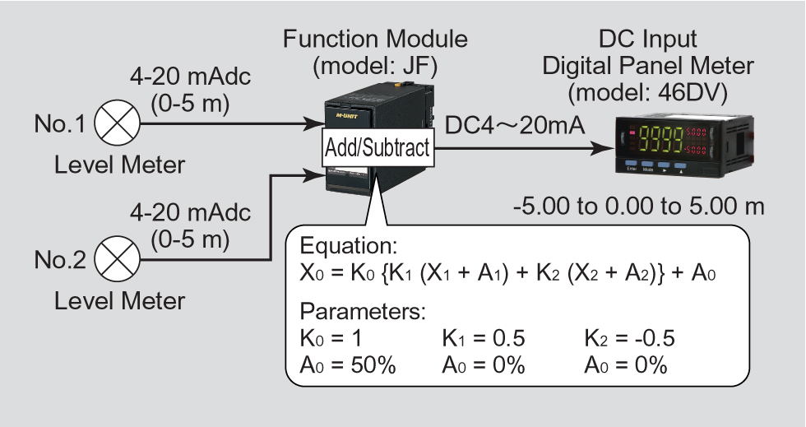

When you specify the scaling for the digital panel meter, 46DL as -5.00 m to +5.00 m corresponding to the 4-20 mA signal from the JF unit then you can see the display value as requested. 

