Emergency Supervision for Power Facilities
M-System’s MSR128 series is a Windows-PC-based recorder software program, which connects to economical I/O modules such as models RZUS, RZMS, R1M, R2M, R3 and R5 for DC mV, mA, thermocouple, RTD/potentiometer inputs and discrete I/Os. The MSR128 is fully featured enabling the logging, trending, acquisition and analysis of application data. Combined with I/O modules, the MSR128 provides a low cost industrial grade data acquisition system.

A common hindrance to efficient time and resource management is multiple field monitoring locations. In this type of situation, being in the right place at the right time can be an exercise in futility.

This type of application was recently adapted using the R3 Series modules (including Ethernet adapter), and the PC Recorder software.

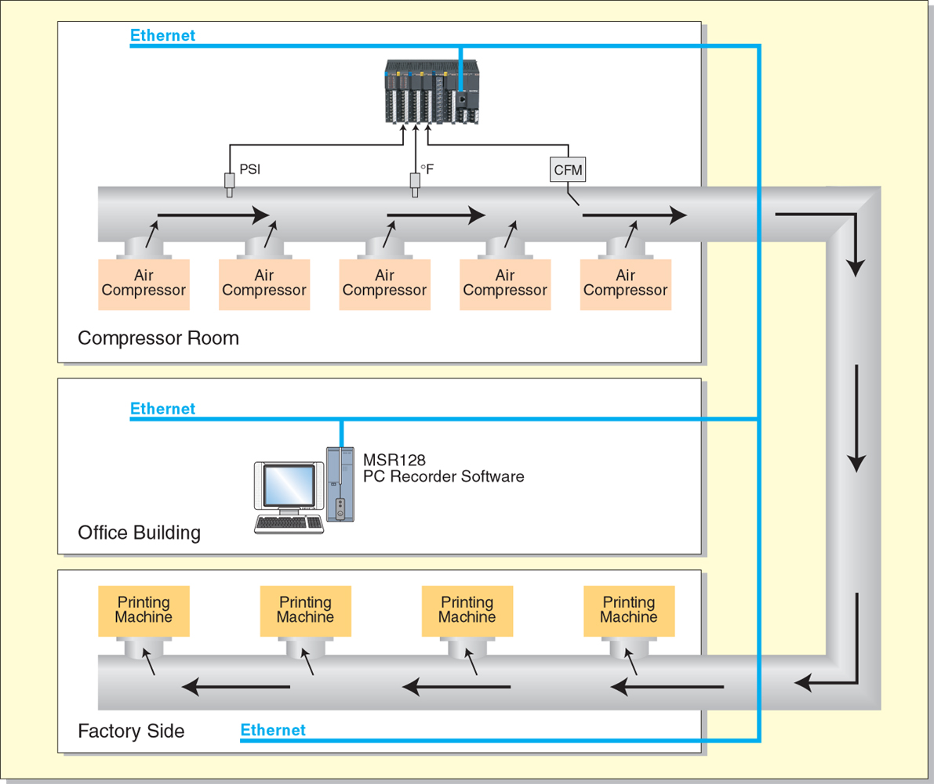
Printing Labels on various media such as bags, boxes and other containers; uses quite a few different resources, one of which is HVLP air. HVLP (High Volume Low Pressure) compressed air is used in this process to dry the ink that has just been printed. The air is supplied by large air compressors, and delivered to each printing machine via a large system of pipes and hoses. Monitoring the air pressures and volumes are very important, and keeping an eye on compressor operation is also key.

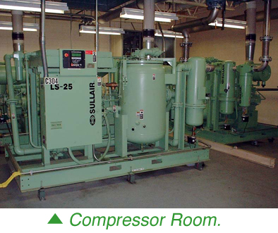
After a recent expansion, it was realized that they had not made any provisions for monitoring the new sites and their air delivery systems. It was decided to try a new approach to this problem. They had researched a few PC based systems, but the harsh environment (heat, humidity, etc) would have destroyed a PC in a matter of weeks.

An M-System R3 rack was put into place in the Compressor Room, and setup to monitor the system air pressure (psi), air flow (cfm), and the air temperature (°F). With these three parameters, many things can be observed.

If air pressures suddenly drop, a leak may have developed. If the flow increases over the course of a year, a machines seals may be going bad, etc.
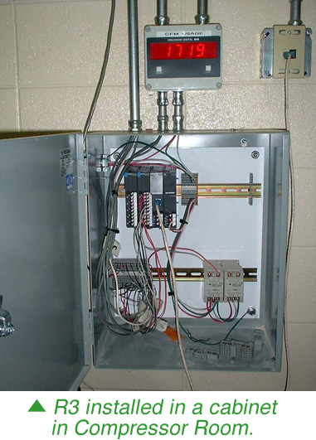
With the PC Recorder software, all of these parameters can be monitored for any period of time!

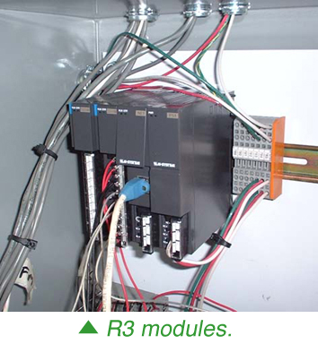
This company will expand their functionality by monitoring the compressor electrical draw, pressures and flow at each printing machine, electrical draw at each machine, and compressor temperature.

All of these inputs will be monitored from one PC in the Maintenance Supervisors office, no special wiring had to be done, and there are no issues with wireless communications.

