Environmental Monitoring
M-System’s MSR128 series is a Windows PC based recorder software program, which connects to economical I/O modules, such as models RZUS, RZMS, R1M, R2M, R3 and R5 for DC mV, mA, thermocouple, RTD/potentiometer inputs and discrete I/Os. The MSR128 is fully featured enabling the logging, trending, acquisition and analysis of application data. Combined with I/O modules, the MSR128 provides a low cost industrial grade data acquisition system.

Environmental controls enforcement is becoming more stringent due to security as well as pollution mandates from local, regional and federal governments. As these controls increase, there is an increasing amount of applications for monitoring environmental data to confirm it is within regulation.

To keep expensive measuring equipment installed all the time is difficult and can be hazardous. So, it is becoming common to move from point to point to take measurements.

In many of these cases, a PC recorder was used to create the record of outdoor environmental measuring equipment, and was also easier to move from location to location.

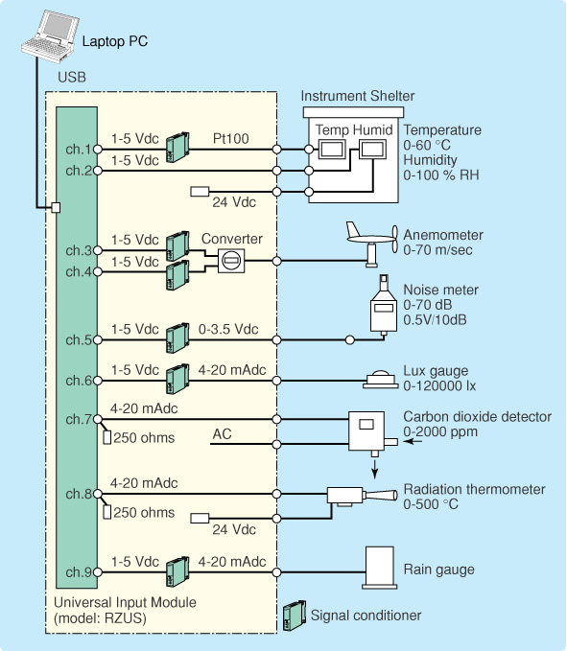
Many successful applications measured temperature and humidity in an instrument shelter; wind velocity and direction of the wind were measured with an anemometer; other measurements taken include noise, illumination, carbon dioxide, radiation temperature, precipitation, underground temperature and others.

When less permanent sites were monitored, a sensor was installed in a tripod base for stability. To offer a complete packaged solution for these applications, M-System’s USB bus-powered PC recorder, the RZUS, stored in a field case, and a cable from the sensor were all that was needed to accurately monitor and record field signals.

Using MSR128, the PC recorder software, users will be able to monitor up to 128 signals. The software has versatile screen features showing multi-view, overview, digital and analog readout among others.

