Pump Station Monitoring Using Paperless Recorder
M-System’s MSR128 series is a Windows PC-based recorder software program, which connects to economical I/O modules such as models RZUS, RZMS, R1M, R2M, R3 and R5 having inputs of DC mV, mA, thermocouple, RTD/potentiometer and discrete I/Os. The MSR128 is fully featured enabling the logging, trending, acquisition and analysis of application data. Combined with I/O modules, the MSR128 provides a low cost industrial grade data acquisition system.

M-System’s 73VR series is a panel-mount paperless recorder. It replaces old paper recorders with an economical, maintenance free paperless recorder, and allows users to monitor standard field signals as well as AC voltage, AC current and CT inputs.

The 73VR3000 is a 4.7-inch STN LCD chart recorder that uses the R3 series modules to monitor input signals. It will use up to four (4) input modules mounted on the rear side of the recorder/viewer module. This provides a simple solution while still maintaining the wide versatility of available types of signal combinations that has made M-System a vendor of choice in many applications.

Success Story — Pump station monitoring
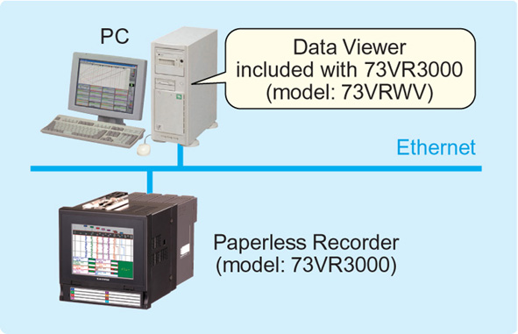
Customer was previously using a paper recorder at a pump station for storm-water control. They record the pump’s operating condition and water level. When it rains, they must check the ever-changing water level on the chart paper, which is time consuming and due to the quantity of variables has caused poor readings and pump breakdowns. By replacing the existing paper chart recorder with the M-System 73VR3000, the customer was able to record measurement history continuously. They could also store the data and easily monitor the trend data on a PC during a heavy rain, and then compare before and after rainfall data in further depth by exporting the data file to Excel.

Usually operated alone, the 73VR3000, can also be connected to a networked PC over Ethernet allowing the customer to check the ever-changing water level when heavy rain is forecasted. The 73VRWV data viewer is included in the 73VRPAC application software CD, which comes with 73VR3000 when ordering. The 73VRWV data viewer may also be used to show and analyze recorded data from the unit’s CF (compact flash) Card. The 73VR3000 data file is converted into the 73VRWV’s MSVD data file using FTP. Date and time stamp at the start and end of data trending may also be specified.

The storm-water level and pump data is stored as a CSV file to allow the customer more efficient and more detailed analysis of the ever-changing field conditions.

As an additional benefit, the 73VR3000’s CF Card may be removed during recording. The data sampled while the card is not inserted is stored in the 73VR3000’s internal memory. It has capacity to allow data to be stored for approximately 5 minutes without a card in the recorder. When the new CF Card is inserted, the data in the internal memory will be automatically copied to the CF Card. Therefore, when replacing CF Card, continuous recording is available without losing any data.

