Temperature Monitoring at Food Manufacturing Plant
M-System’s MSR128 series is a Windows PC-based recorder software program, which connects to economical I/O modules such as models RZUS, RZMS, R1M, R2M, R3 and R5 having inputs of DC mV, mA, thermocouple, RTD/potentiometer and discrete I/Os. The MSR128 is fully featured enabling the logging, trending, acquisition and analysis of application data. Combined with I/O modules, the MSR128 provides a low cost industrial grade data acquisition system.

M-System’s 73VR2100 series is a panel-mount paperless recorder. It replaces old paper recorders with an economical, maintenance free paperless recorder, and allows users to monitor standard field signals.

The 73VR2100 series has a 5.5-inch TFT LCD used for recording 2, 4 or 6 universal inputs. Sampled data is stored in a CF Card and monitored locally on the screen or at the host PC via Ethernet.

Success Story — Temperature monitoring at food manufacturing plant
The customer was previously using paper recorders at their food manufacturing plant for the temperature monitoring. They recorded the water level of the ingredient tank and the temperature of the food blending tank. There are various tanks at their plant, where paper recorders were installed at each tank. This required troublesome and time consuming maintenance including ink blockage, ink outage, paper jam, and paper outages. When customer replaced existing paper recorders with M System’s paperless recorder, the 73VR2100 series, the cost of supplies and man hours previously required to maintain paper recorders were drastically reduced.
Table 1. 73VR2100 Series Input Points.
Input Points | Model No.
2 points | 73VR2102
4 points | 73VR2104
6 points | 73VR2106

Using the 73VR2100 series, monitoring data can be viewed real time at the site, and also additional useful features including alarm history and overview are provided that were not available on the customers old paper recorders.
Table 2. 73VR2100 Series Input Types.
DC voltage | ±60mV, ±125mV, ±250mV, ±500mV, ±1000mV, ±3V, ±6V, ±12V
T/C | K, E, J, T, B, R, S, C (Wre5-26), N, U, L, P (Platinel), (PR)
RTD | Pt 100, Pt 200, Pt 300, Pt 400, Pt 500, Pt 1000, Pt 50, JPt 100, Ni 100, Ni 120, Ni 508.4, Ni-Fe 604, Cu 10

Above all, the 73VR2100 series is highly regarded by customers with its feature of Ethernet communication. The plant manager can remotely monitor data of water level and temperature from the tanks in the field. At his PC, using dedicated recorder software MSR128, real time monitoring is available. Stored data and alarm history files can be converted into CSV allowing easy export to other Windows programs such as Microsoft Excel.
Figure 1. 73VR210x views.
 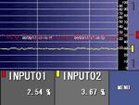 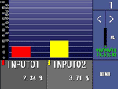
Trend (perpendicular). Trend (horizontal). Bargraph.

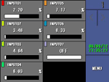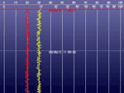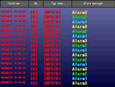
Overview. Retrieve. Alarm history.

Figure 2. System configuration.
