Data Acquisition from Fuel Cell Test Equipment
M-System’s MSR128 series is a Windows PC-based recorder software program, which connects to economical I/O modules such as models RZUS, RZMS, R1M, R2M, R3 and R5 and has inputs of DC mV, mA, thermocouple, RTD/potentiometer and discrete I/Os. The MSR128 is fully featured enabling the logging, trending, acquisition and analysis of application data. Combined with I/O modules, the MSR128 provides a low cost industrial grade data acquisition system.

Success Story — DATA ACQUISITION FROM FUEL CELL TEST EQUIPMENT
The customer was looking for a solution to realize the following conditions:

- Use a single PC for data acquisition
- There are 3 (three) locations for data monitoring. Each location has 12 points of temperature and pressure signals. Data file is required to store per location.
- Monitoring hours differ by location, thus remote triggers are required to start recording each location separately.
- Alarm trip to output at each cell block location for temperature anomalies and other variables.

Signals are RTDs from temperature sensors and 4-20mA DC from pressure sensors. The model RZMS-U9, with 12 points universal input, will be used providing channel to channel isolation, remote trigger and alarm outputs. Three units of RZMS-U9 are networked over RS-485 (Modbus RTU). (Figure 1)

Figure 1. System configuration.
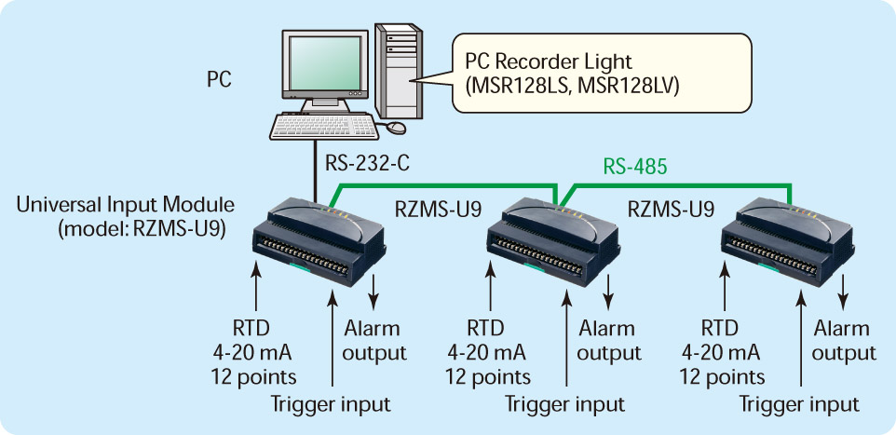
In conjunction, the PC recorder software to be used is the MSR128-Light (MSR128LV, MSR128LS). The MSR128-Light is designed to operate on a PC with relatively low performance. Even a Windows 98 PC may be utilized, though certain functions of the MSR128 which require the PC’s high performance, will not be available.

MSR128LV, MSR128LS service channel numbers 120 maximum, using Group 1 through Group 10 views (12 channels/group). A data file is created per group and may be saved in CSV format allowing for easy export to other Windows programs such as Microsoft Excel.

Remote Trigger mode (Figure 2): The MSR128-Light stores data only when a predetermined condition is true (the remote trigger contact signal is either ON or OFF).

Figure 2. Store setting
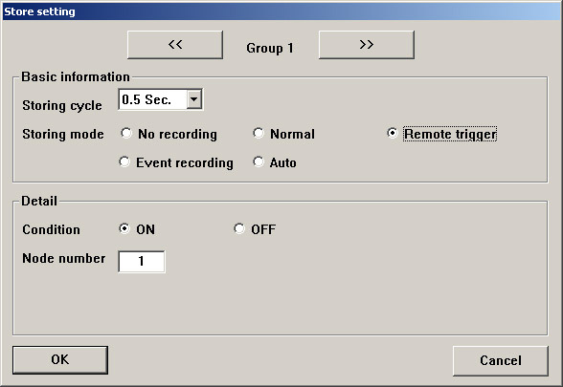

• Condition: Specify whether the recorder should identify ON or OFF of the contact signal as a trigger condition.

For example, when the State is set to ON, the MSR128-Light stores data while the signal is ON and stops recording when it is turned to OFF.

• Node Number: Specify which device connected to the MSR128-Light is used to trigger the recording. In our case, the trigger input terminal equipped on the analog input module, the RZMS, is used.

Alarm Setpoint (Figure 3)
Specify Lower and Upper setpoints in an engineering unit within the Engineering Range. The alarm trips when the signal goes above the upper setpoint and below the lower setpoint.

Figure 3. Pen setting
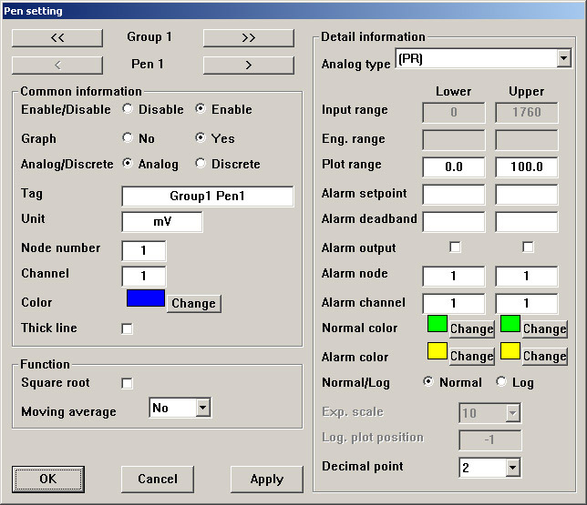

Alarm Node & Channel
Specify Node Number and the Channel Number of the output module. For using the built-in contact output for models R1MS-GH3, RZMS-U9, R2M-2H3 and R2M-2G3, specify ‘Channel 1.’

These are just a few of the features of the MSR128-Light and RZMS that have come to be highly regarded by customers along with providing a cost effective solution for their needs.

