Paperless recorder for the sterilizer system at food manufacturing plant
M-System’s 7xET series is a Windows CE based touch-panel display installed with simplified on-site PC Recorder software. Data from PC Recorder I/O modules can be transferred via Ethernet in real time to the PC Recorder Software (MSR128) installed in a host PC. It can also function as an independent local site recorder in conjunction with I/O modules connected via RS-232C or RS-485. Data can be then stored in a CF card, retrieved and edited on the MSR128 separately. A wide selection of Modbus I/O modules compatible with M-System’s PC Recorder series are also available.

M-System’s MSR128 series is a Windows PC-based recorder software program, which connects to economical I/O modules such as models RZUS, RZMS, R1M, R2M, R3 and R5 and has inputs of DC mV, mA, thermocouple, RTD/potentiometer and discrete I/Os. The MSR128 is fully featured enabling the logging, trending, acquisition and analysis of application data. Combined with I/O modules, the MSR128 provides a low cost, industrial grade data acquisition system.

Success Story - Data acquisition from sterilizer system at food manufacturing plant
The customer was using a paper based chart recorder previously but wanted to more easily log and trend his data in a more economical method. The application was to record temperature input and the elapsed time of processing powder; to heating it to specific temperature and sterilize it. Their sterilizing system is to process food product materials (powders), including such items as curry powder.

The customer was looking for a solution-solving product that could meet their requirements:

- To reduce the constant mechanical troubles the existing chart recorder was having due to vibrations caused by the sterilizer unit used to blend powders.
- To reduce paper waste caused by existing paper recorders.

M-System’s 7xET series is a chartless recorder, storing data into a CF card. Stored data in a CF card is portable and usable on an independent PC for further analysis. The 7xET has an Ethernet interface, which provides access from an office based PC or one residing on a LAN.

Ethernet communication transmits data of specific channels stored in real time to a host PC installed with the PC Recorder Software Model MSR128. Data stored in the CF Card can be uploaded to the MSR128 using FTP protocol.

By using MSR128, data transferred to a PC can be recalled, edited and used to be printed as hard copies or to be exported to spreadsheets for further analysis. Data is stored in binary format and exportable to CSV format, which can be further converted to popular spreadsheet software packages, such as Microsoft Excel.

The 7xET is a touch panel display, installed with M-System’s Paperless Recorder Software, recording 128 points maximum. Various types of I/O modules are selectable to connect to the 7xET. The R1M/R2M is connected via a RS-232C cable, or extended via RS-485 by inserting a RS-232C/RS-485 converter (model: R2K-1). The R5-NM1 or R3-NM1 and other modules, up to 15 in total, can be connected via RS-485 twisted-pair cable.

The 7xET system is highly regarded by customers for easy maintenance compared to traditional chart recorders, due to its ability to significantly reduce the running cost of supplies and labor. It also provides data analysis by a PC allowing for improved efficiency of their work.

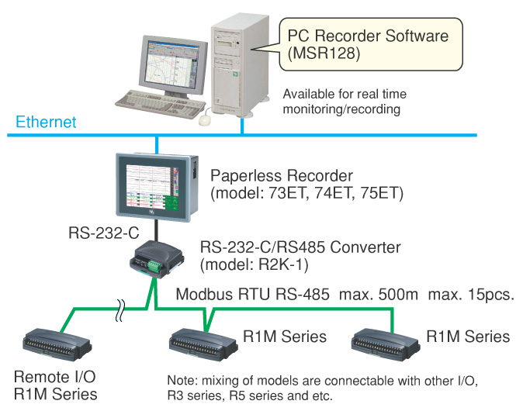
Figure 1. System configuration

