Temperature monitoring of continuous kiln
M-System’s 73VR3100 is a panel-mount paperless recorder. It replaces traditional paper recorders with a more economical, maintenance free paperless recorder, and allows users to monitor standard field signals.

The 73VR3100 has a 5.5-inch TFT LCD used for recording. Up to four input modules selected from the R3 series, can be mounted on the rear side of the recorder/viewer module. This provides a simple solution while still maintaining a wide versatility in signal type combinations.

The measured data is transferred in real time to the host PC via Ethernet, and then can be viewed and stored on the MSR128 PC Recorder software program. The MSR128 used with the 73VRWV Data Viewer can retrieve data stored in the CF Card via Ethernet FTP without interrupting data being recorded on the 73VR3100.

By replacing one of the I/O modules with a Network Module for the R3 Series, the 73VR3100 can directly communicate to most of the major PLCs via CC-Link, DeviceNet, Modbus, Ethernet (Modbus/TCP), LONWORKS and PROFIBUS-DP.

Success Story — Temperature monitoring of continuous kiln
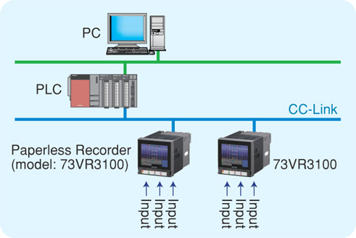
The customer was previously using paper recorders at their plant where there are eight continuous kilns used for the firing of various ceramic parts. Each kiln uses around 24 type K thermocouples. These temperatures were previously monitored using a traditional paper recorder. Temperature data management was handled by reading data recorded on a chart and manually inputting that data to a PC. Traditional recorders also require yearly calibration and on going costs, such as paper and pen replacement. The customer was wanting to more accurately collect and manage their data while realizing cost savings. The solution should also be able to monitor data both at panel in the field and at a control room remotely located.

Using M-System’s paperless chart recorder, the 73VR3100, the customer found a solution that met all of their requests. It was mounted in the field panel providing local monitoring and was also able to transmit the data to a PC in the control room via PLC on a CC-Link communication module installed in the 73VR3100.

The 73VR3100 will accept up to four (4) input modules, or one may use one of the slots for a network module. In this customer’s application, three (3) R3-TS8 (isolated, 8 channel thermocouple module) and one (1) R3-NC3 (CC-Link network module) were used.
In the plant, there is one control panel per each kiln. There were three (3) paper recorders per panel, with each requiring regular maintenance such as paper jams, ink blockages, changing paper, lubricating mechanical parts, and others.

Using the 73VR3100, real time data monitoring became available using only one unit per panel, and additional features including alarm history and alarm overview were available, which the paper recorders did not have. The operator could also check the history of trouble by the alarm history screen, and the status of all channels can be viewed at one time by alarm overview. M-System’s 73VR2100 also improved their workability and allowed them to respond more quickly to breakdowns and alarms. Also, the cost of supplies and man-hours previously required to maintain paper recorders were drastically reduced.

The 73VR3100 is highly regarded by customer, and they are pleased with the ability to have real time monitoring in their office for the temperature data of all of their kilns in the plant.

Data transmission to the PLC was mandatory and used to be accomplished by hard wiring signal splitters (single input, dual output signal conditioners). The M-System solution allows the customer to receive the additional benefit of the network module (R3-NC3) installed in 73VR3100 sending data to the PLC over the CC-Link communication bus.
