Temperature monitoring at a synthetic fiber plant
M-System’s MSRpro is a ‘paperless pen-type’ recording system for PC-based data acquisition and analysis, supporting a total of 2048-channel analog and discrete signals. By employing the R3 Series Remote I/O as an input device, a wide variety of field sensor signals including temperature, DC and AC, relays and open collectors can be handled. In addition, various math and filter functions can be applied to the input signals in order to maximize the benefit of the expanded analytical functions of MSRpro. Utilizing just one PC, which can run both the Server and the Client, up to 512 points can be monitored. The Server and Client should be installed on independent PCs for additional input signals. Four Client PCs can access the Server with up to 8 field stations able to be connected. The MSRpro, model MSR2K, is a suite of three programs: the MSRpro-Server (referred hereafter as ‘Server’), MSRproBuilder (‘Builder’), and the MSRpro-Client/Analyzer (‘Client’). This software package provides a simple solution while still maintaining the wide versatility of available types of signal combinations that has made M-System a vendor of choice in many applications around the world.

Success Story - Temperature monitoring at a synthetic fiber plant
The customer was looking for a solution to replace paper chart recorders, which were being used to monitoring temperature at their synthetic fiber plant.

One of the processes at the plant is designed to make otherwise useless non-standard products that are generated during the synthetic fiber manufacturing process into chips to facilitate their reuse. During this process, newly made chips are dried with a hot air drier called a power drier. The monitoring of the temperature of this piece of equipment was the reason that the PC recorder was selected.

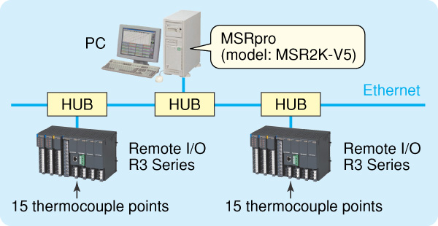
Figure1. System Configuration

Previously the customer had been using a paper chart recorder to monitor over 30 points of temperature data. Many years had passed since the customer had installed the original paper recorder, and the customer was considering a replacement. Initially the customer was considering the replacement of an identical paper chart recorder since they had experience using it and were familiar with its operation. However, the high cost of doing so, coupled with the need for maintenance when the unit experienced a paper jam or ran out of paper ultimately led the customer to opt for a maintenance-free PC recorder, and they chose M-System’s MSRpro.

The most significant factor in their decision was that the M-System configuration could be easily built and at a low cost. The customer was able to achieve dramatic cost savings compared to a chart-type recorder by using R3 Series remote I/O units.

Another point in the MSRpro’s favor was the ability for users to configure their own settings. It would be extremely expensive to operate the system if adding data display points or changing the display method or range necessitated calling in a representative from the software manufacturer. By contrast, the customer appreciated the fact that MSRpro makes it easy for users to change their own settings since it does not use a special language to control the manipulation of settings.

The MSRpro’s password function was another factor in the customer’s decision. Although the ability for users to change their own settings is an advantage, allowing floor workers who are not specialists access to settings screens can be problematic in some cases.

The accessibility of MSRpro and its functions can be determined on a worker-by-worker basis by using the password function, which allows accessibility to be apportioned between workers who can access all operations (all setting changes) and workers who can change only settings such as display and alarm functionality that do not affect critical areas of system operation (This operation is not available when the server is not operating.) (see Table 1). Finally, the application of password restrictions enables users to avoid device down time caused by improper operation.

The customer chose MSRpro PC recorder software (MSR2K-V5) as a result of the features described above, and they remain very satisfied with their choice.

Table 1. Setting Accessible to General Users
Setting category | Configurable parameters
PEN Configuration | Show/Hide, Thick line, Plot position, Logarithm settings
ALARM Configuration | All
TREND Configuration | Pen panel percent (Perpendicular / Horizontal), Connected
ACTIVE TREND Configuration | Pen panel percent (Perpendicular / Horizontal)
OVERVIEW Configuration | Group alarm indicator, Connected
ANALYZER Configuration | Graph brightness
SAVE & READ Configuration | All
Save Configuration in CSV | All

