Monitoring of peak power value a day generated by solar panel


We are looking for a solution to monitor the peak value during a day of generated power by solar panel and display it on a large digital panel meter. The rated output from a solar panel is 0 to 24V and 0 to 8A DC.


We propose a combination of using the following signal transmitters. (Figure 1)
2 pcs. Signal Transmitters (model: M6DVS)
1 pc. Math Function Module (model: M6DXF2)
1 pc. Peak-hold Function Module (model: M6DVF3)
The M6DVS units to select 1 to 5V DC output for the measured values of 0 to 24V DC and 0 to 50mV DC (converted 0 to 8A by a shunt resistor). The M6DXF2 is used to multiply two input signals from them, and its output of either 1 to 5V or 4 to 20mA DC is transmitted to the M6DXF3. The peak-hold function of M6DXF3 enables its output of the peak value during a day. 
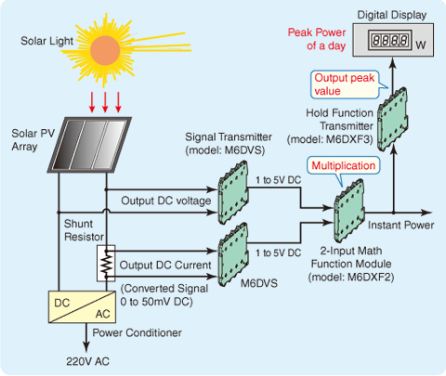
Figure 1

