Mini-M series, Parameter Generator M2MST for various parameter settings.


We are upgrading a panel, and the Mini-M signal conditioners will be used. Those include the following models and etc. Current Loop Supply (model: M2DYS), Signal Transmitter (model: M2VS), RTD Transmitter (model: M2RS). Prior to the system start-up, loop tests are planned to conduct for the output loops of their signals. Signal generators can be used but it requires various types of signals and additional work for rewiring. Do you have a product which we can use with their base sockets and output the simulated 4 to 20mA DC signal?


M-System’s Parameter Generator (model: M2MST) is plug-in compatible and can be used as a signal generator. The setpoint display shows the current setpoint (-10.0 to +105%). Press UP/DOWN control switches until the display shows a desired set value by 0.1% increments (1% increments over 100%). (Figure 1)

Note: The M2MST is available with DC analog output only. Other output types are not applicable (e.g. pulse, discrete). 

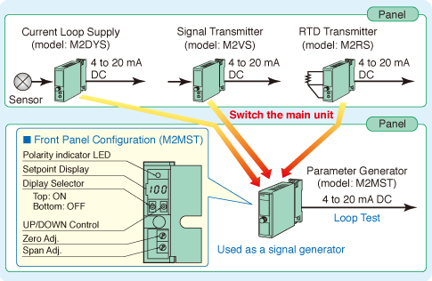
Figure 1

