DeviceNet actuator


For the production of pasta, there is a mixing process of raw materials in a tank. The raw materials can be affected by heat. To prevent it, the water temperature surrounding the tank is adjusted by controlling the valves of cold-water and heated-water. This time, we are considering a PLC to control the temperature automatically. The DeviceNet communication bus is ideal to control the valves. Is there any suitable product?


M-System's Mini-Top DeviceNet rotary actuators (model: MRP4D, MRP5D, MRP6D) allow valves to be precisely controlled and their position monitored using industry standard network interface. Additional information includes actuator's self-diagnostics, configuration parameters, accumulated operational time, serial number and general serviceability data. This information can be used for maintenance scheduling to reduce system downtime. The model selection is available by operation time and torque. 

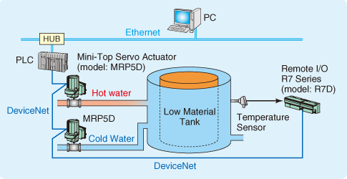
Figure 1

